* Nhóm các Constraint thành 1 nhóm để validate trong 1 lần

Default thì tất cả constraints sẽ được group vào **Default.class**

* VD:

**First validation**: user cung cấp basic information (first name, last name, email id, phone number, and captcha)

**Second validation**: user cung cấp thêm address(street, house number, zip code, city, country) và vẫn validate captcha

**

*Declaring Constraint Groups*

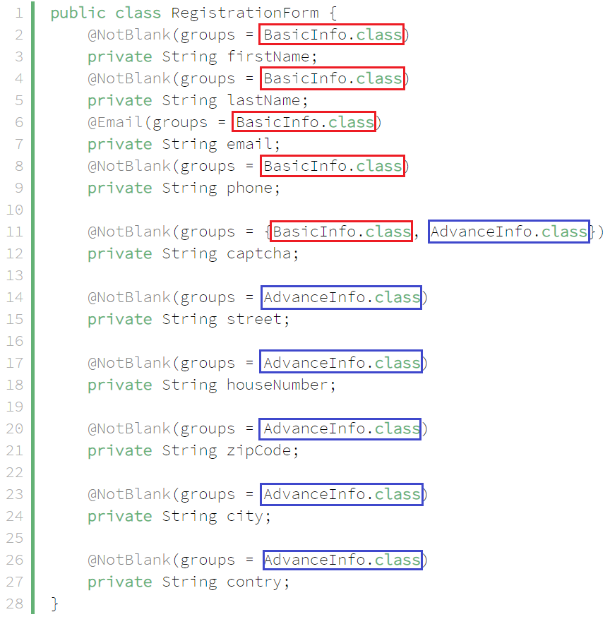

*Using*

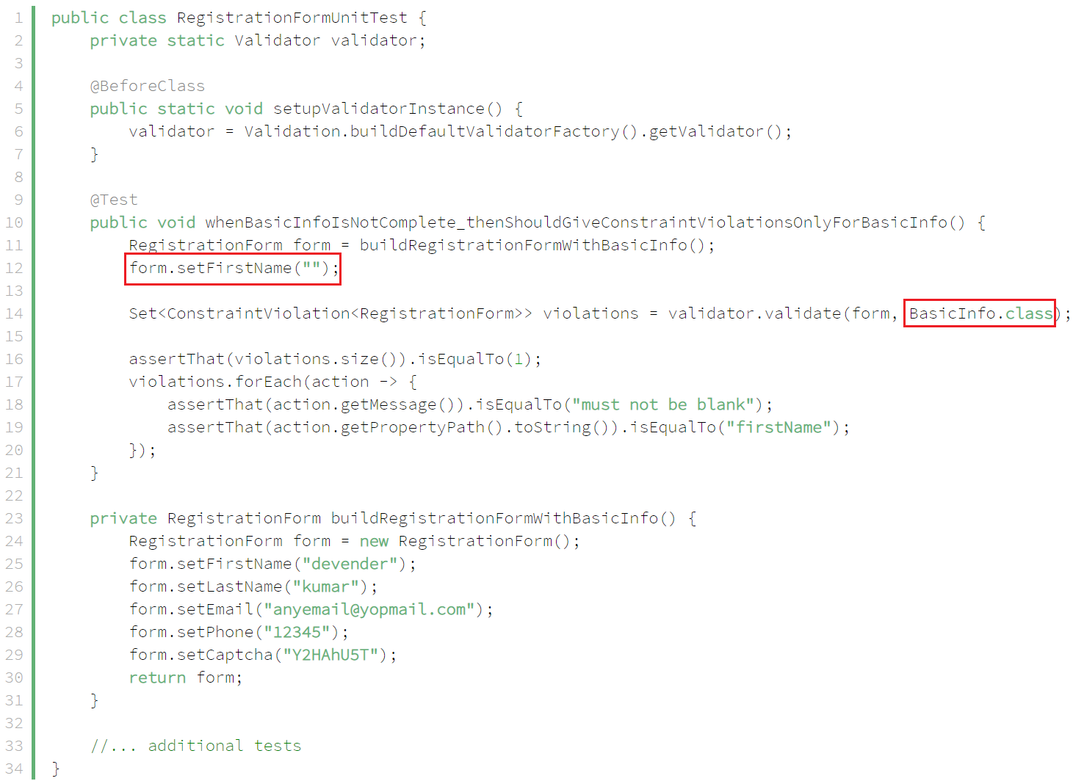

*Validate first validation*

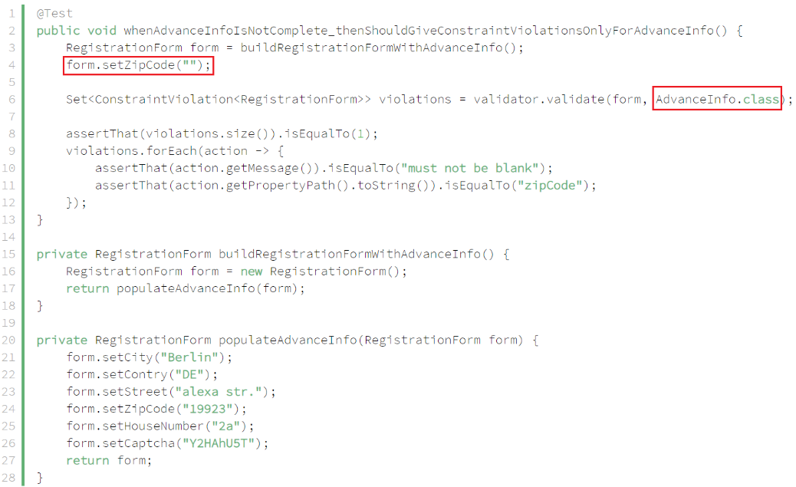

*Validate second validation*

* **Group Order**
  + **Cách 1: Sử dụng @GroupSequence** 
    - **on the entity**

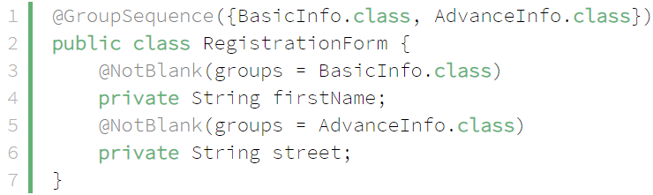

*Fixing*

* + - **on an Interface**

VD:

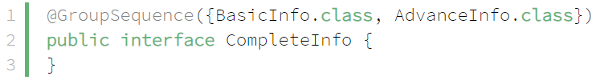

*Interface ordering*

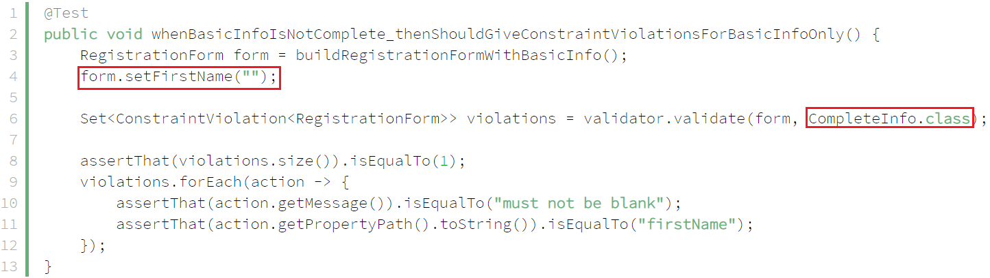

*Validate (BasicInfo is incomplete 🡺 AdvanceInfo will not be evaluated)*

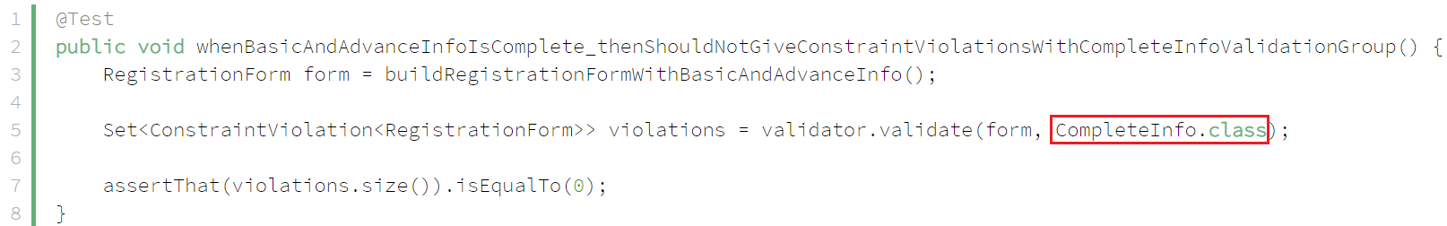

*Validate (BasicInfo is complete 🡺 AdvanceInfo should be evaluated)*

* + **Cách 2: sử dụng trong validator.validate()**

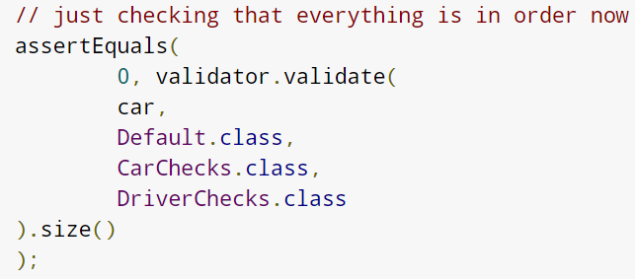

<https://docs.jboss.org/hibernate/stable/validator/reference/en-US/html_single/#_requesting_groups>

* **Custom Default Group**

<https://docs.jboss.org/hibernate/stable/validator/reference/en-US/html_single/#section-default-group-class>

* **Reference**

<https://www.baeldung.com/javax-validation-groups>

<https://docs.jboss.org/hibernate/stable/validator/reference/en-US/html_single/#chapter-groups>